EC 2

Table of Contents
Elastic Compute Cloud – Part 1 2
What is EC2 2
Elastic Compute Cloud – Part 2 4
Launch our first EC2 Instance – Lab 1 8
Launch our first EC2 Instance – Lab 2 9
Security Groups Lab 10
Volume & Snapshot Lab 11
Raid Volumes & Snapshops 12
Encrypted Root Device Volumes & Snapshots – Lab 14
AMI Types 15
(EMS VS instance store) 15

Elastic Compute Cloud – Part 1

What is EC2
- Web service that provides resizable compute capacity in the cloud. Reduces the time required to obtain and boot new server instances to minutes, allowing to quicly scale capacity, up and down.
- EC2 Options
  - On Demand: allow you to pay a fixed rate by the hour with no commitment.
    - Cost
      - Low cost flexibility without up-front or long term commitment
    - Use Cases
      - Application with short term, spiky or unpredictable workloads that cannot be interrupted.
      - Application being developed or tested on Amazon EC2 for the first time.
  - Reserved: capacity reservation and offer significant discount on the hourly charge for an instance. 1 year or 3 year start.
    - Use cases
      - Applications with stready state or predictable usage.
      - Applications that require reserved capacity
      - users able to make upfront payments to reduce their total computing costs even further with discounts.
  - Spot: enable you to bid whatever price you want for instance capacity, proviging for even greater saving if your applications have flexible start and end times.
    - Cost
      - Spot prices is changing based on regions
    - Use cases
      - Applications that have flexible start and end times
      - applications that are only feasible at very low compute prices
      - users with urgent computing needs for large amounts of additional capacity
    - Exam tip
      - If the spot instance is terminated by Amazon EC2, you will not be charged for a partial hour of usage.
      - However if you terminate the instance yourself, you will be charged for any hour in which the instance ran.
  - Dedicated Hosts: physical EC2 server, dedicated for your use, dedicated hosts can help you reduce costs by allowing you to use your existing server-bound software licenses.
    - Use cases
      - Useful for regulatory requirements that may not support multi-tenant virtualisation.
      - Great for licensing which does not support multi-tenancy or cloud deployments
    - Cost
      - Can be purchased on-demand (hourly)
      - Can be purchased as a reservation for up to 70% off the on-demand price.
- EC2 Instance Types
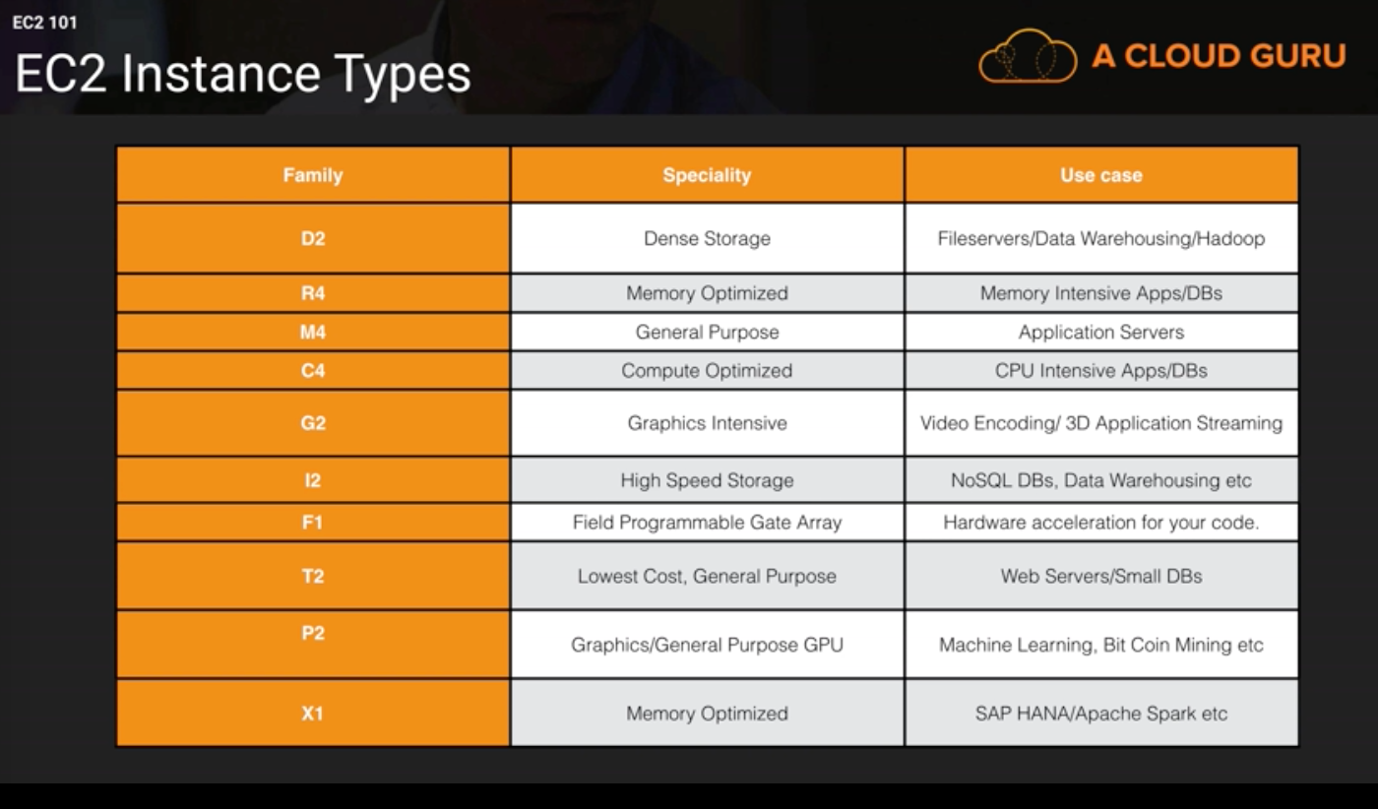
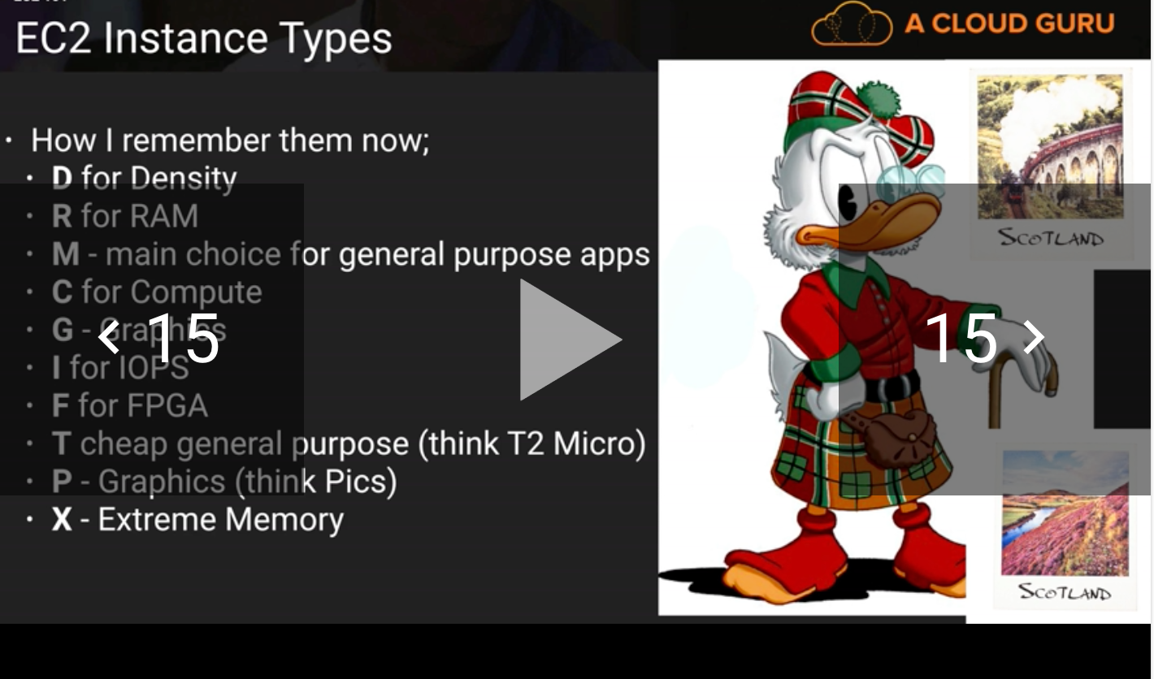

Elastic Compute Cloud – Part 2

- What is EBS (Elastic Block Cloud)
  - Allow to create storage volumns and attach them to Amazon EC2 instances.
  - Once attached, you can create a file system on top of these volumns, Run a database or use them in any other way
  - EBS volumns are placed in a specific availability zone, where are automatically replicated to protect you from the failure of a single component.
- EBS Volume Types

SSD volumes
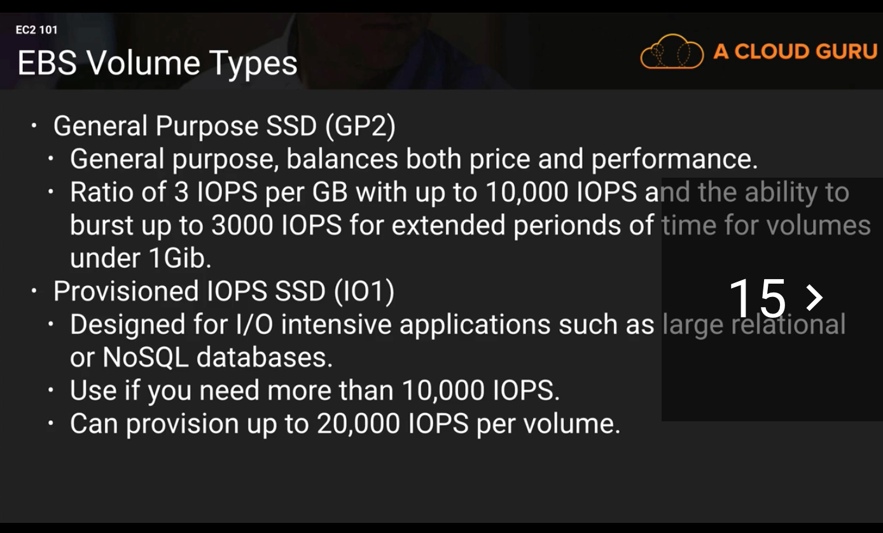

Magnetic storage
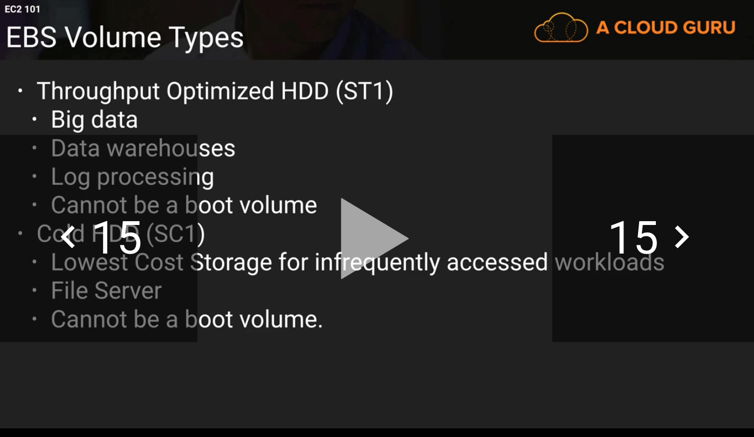
Magnetic Standard
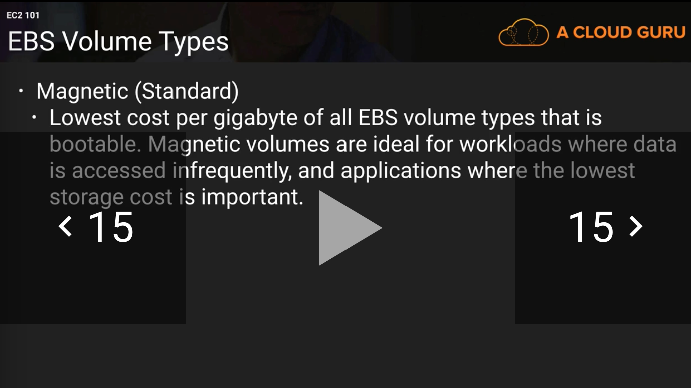
Can be used as OS disks.

Exam Tips EC2
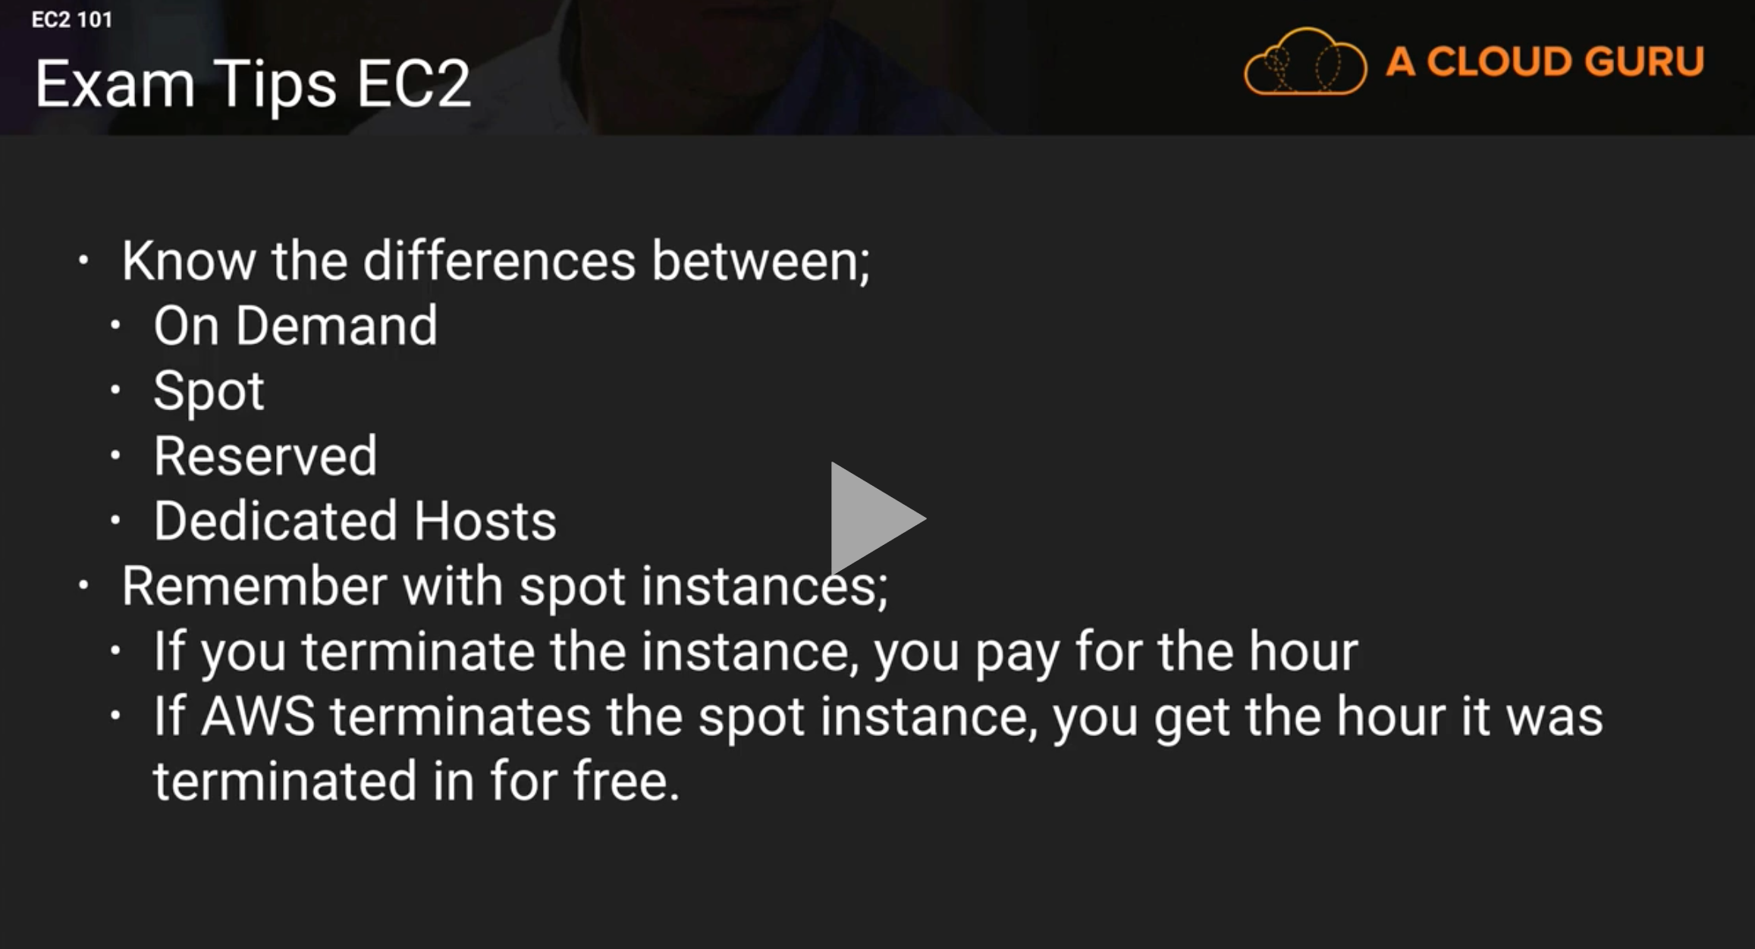
Exam tips EBS
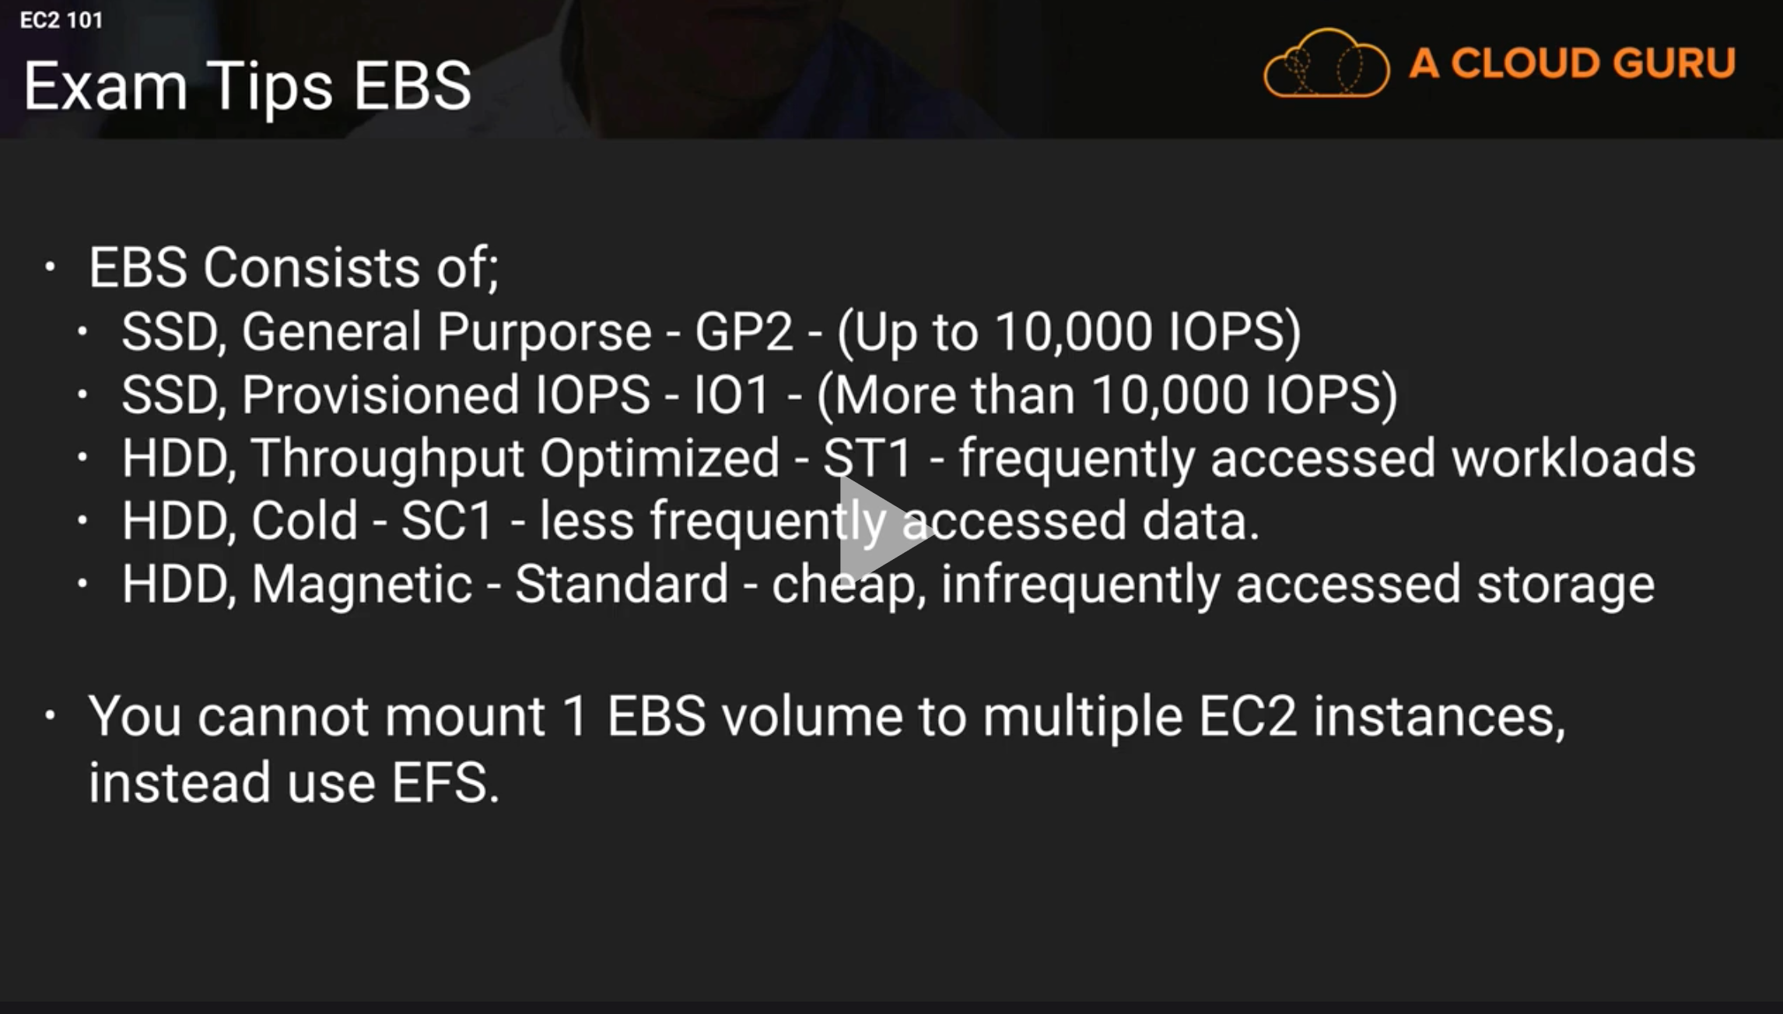

EC2 Instance Types
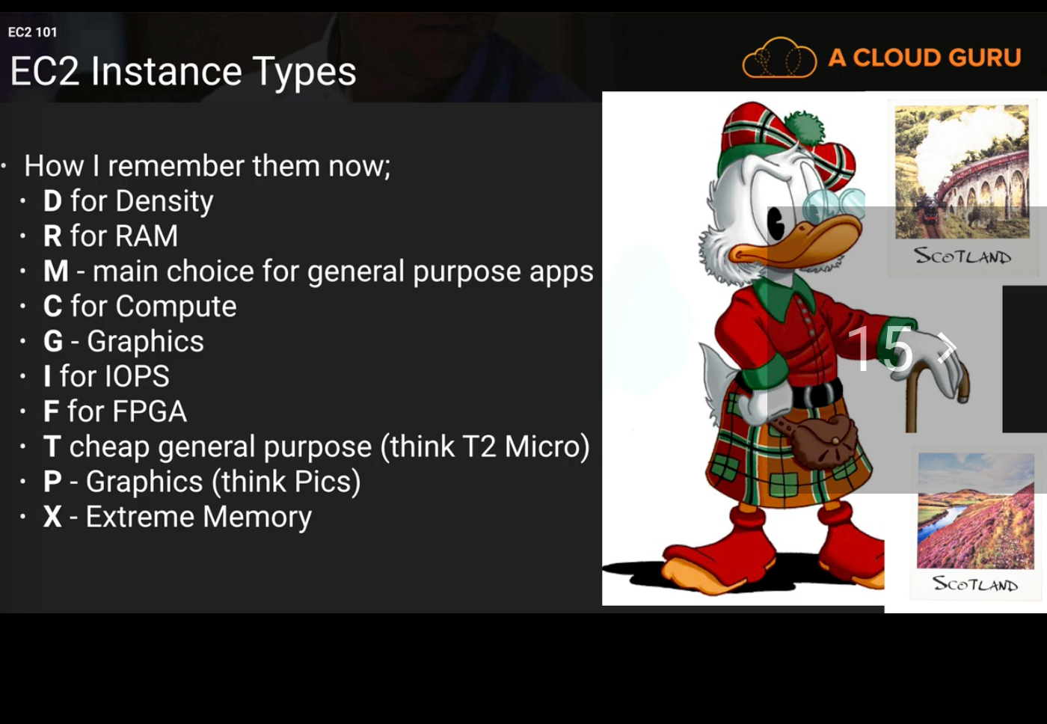

Launch our first EC2 Instance – Lab 1
- Exam
  - What happened to the EBS volume if you delete the EC2 instance attached to it?
    - If on creation if chosed Delete on termination, it will be deleted.

Launch our first EC2 Instance – Lab 2
- System Status Checks
  - Check that the instance is reachable. By sending network packs.
- Instance Status Checks
  - Check the OS is reachable.
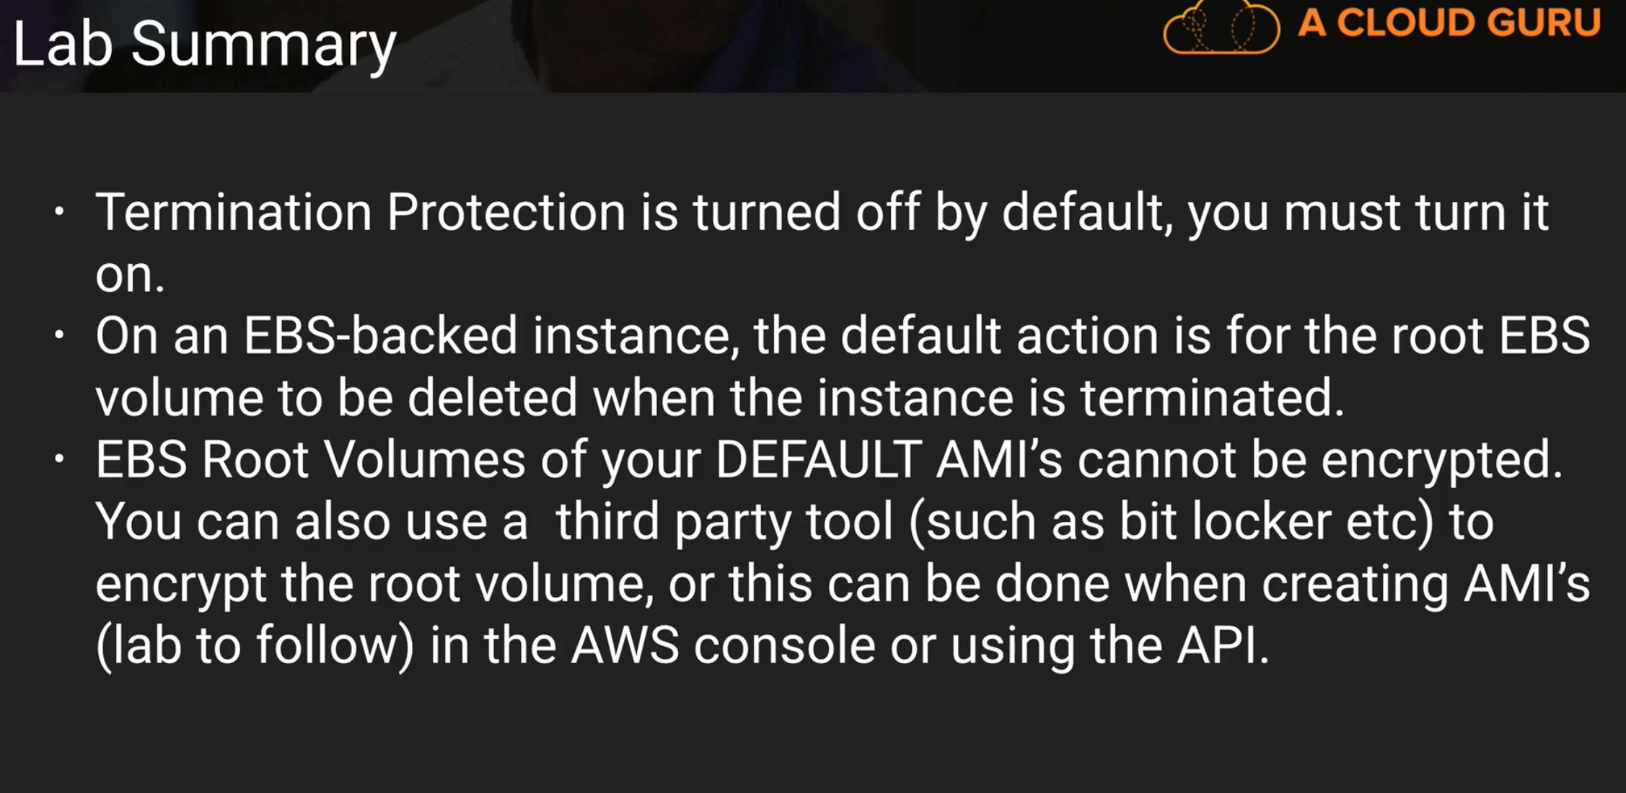
- Additional volumes can be encrypted.

Security Groups Lab
- 1 EC2 instance can have multiple security group.
- First line of defense against hackers.
- Virtual firewall.
- Any security group update is applied immediatally.
- All inbound traffic is blocked by default.
- All outbound traffic is allowed by default.
- Changing security groups is taking effect immediately
- you can relate any number of EC2 with a security group.
- You can have multiple security groups attached to EC2 instances.
- Security groups are stateful
  - if you create an inbound rule allowing traffic in, that traffic is automatically allowed back out again.
  - Security groups are stateful, network access groups are stateless.
  - You cannot block specific IP addresses using security groups, instead use network access control lists.
  - You can specify allow rules, but not deny rules.

Upgrading EBS Volume Types - Lab - Part 1

- Upgrading from testing env to production env for example.
  - Create testSQLDb instance
  - Attach magnet disk storage type
  - Mount to the instance
  - Then upgrade
    - Unmount the magnet disk
    - Detach the magnet disk from the instance
    - Create new IOPS or gp disk
    - Attach it to the instance
    - Mount it to our folder
    - That’s it, you’re updated.

Volume & Snapshot Lab

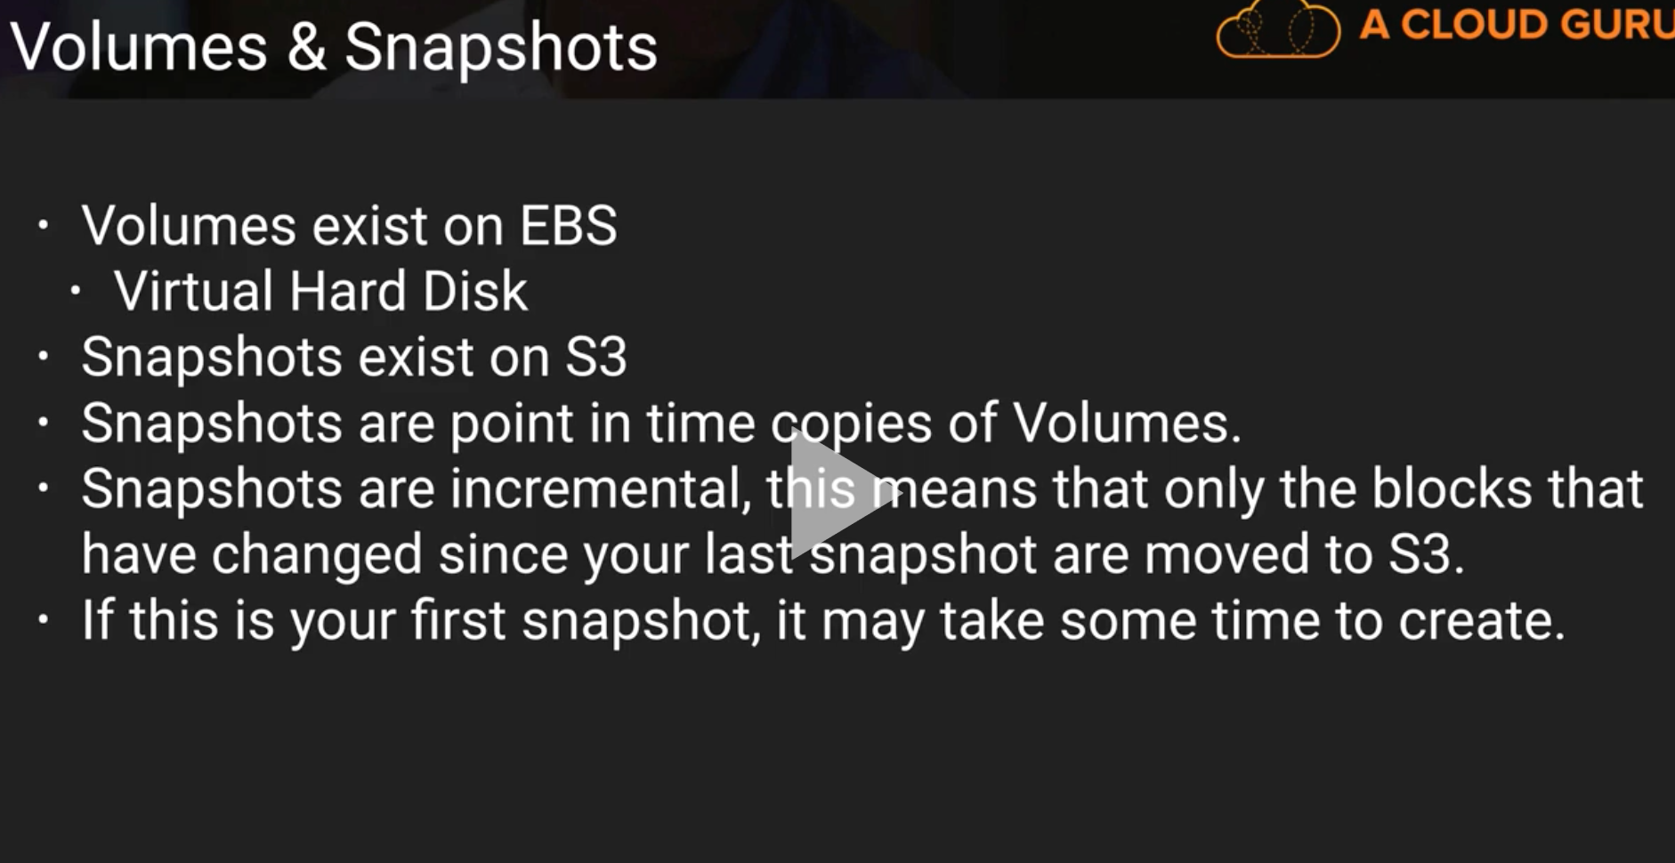

Raid Volumes & Snapshops

RAID = Redundant array of independent disks.
RAID 0 = Sriped, no redunduncy, good performance.
RAID 1 = Mirrored, redunduncy.
RAID 5 = 3 disks or more, good for reads, bad for writes, AWS does not recommend ever putting RAID 5’s on EBS.
RAID 10 = Srtiped, Mirrored, combination of RAID 5 and RAID 0, good redundancy, good performance.
Best combination on AWS if you need more IO to your disk, is to use RAID 0 or RAID 10, to add more IO’s to your instance.
For example if you have a not supported database like Cassandra, you can install it on EBS Volumes with RAID array for better IO performance.
You can create RAID 0, 5 or 10 by creating windows server 12 R2 instance, attaching 4 disks to it, then connecting using RDP to windows desktop, then use Disks utility to create RAID 0 for better IO performance.

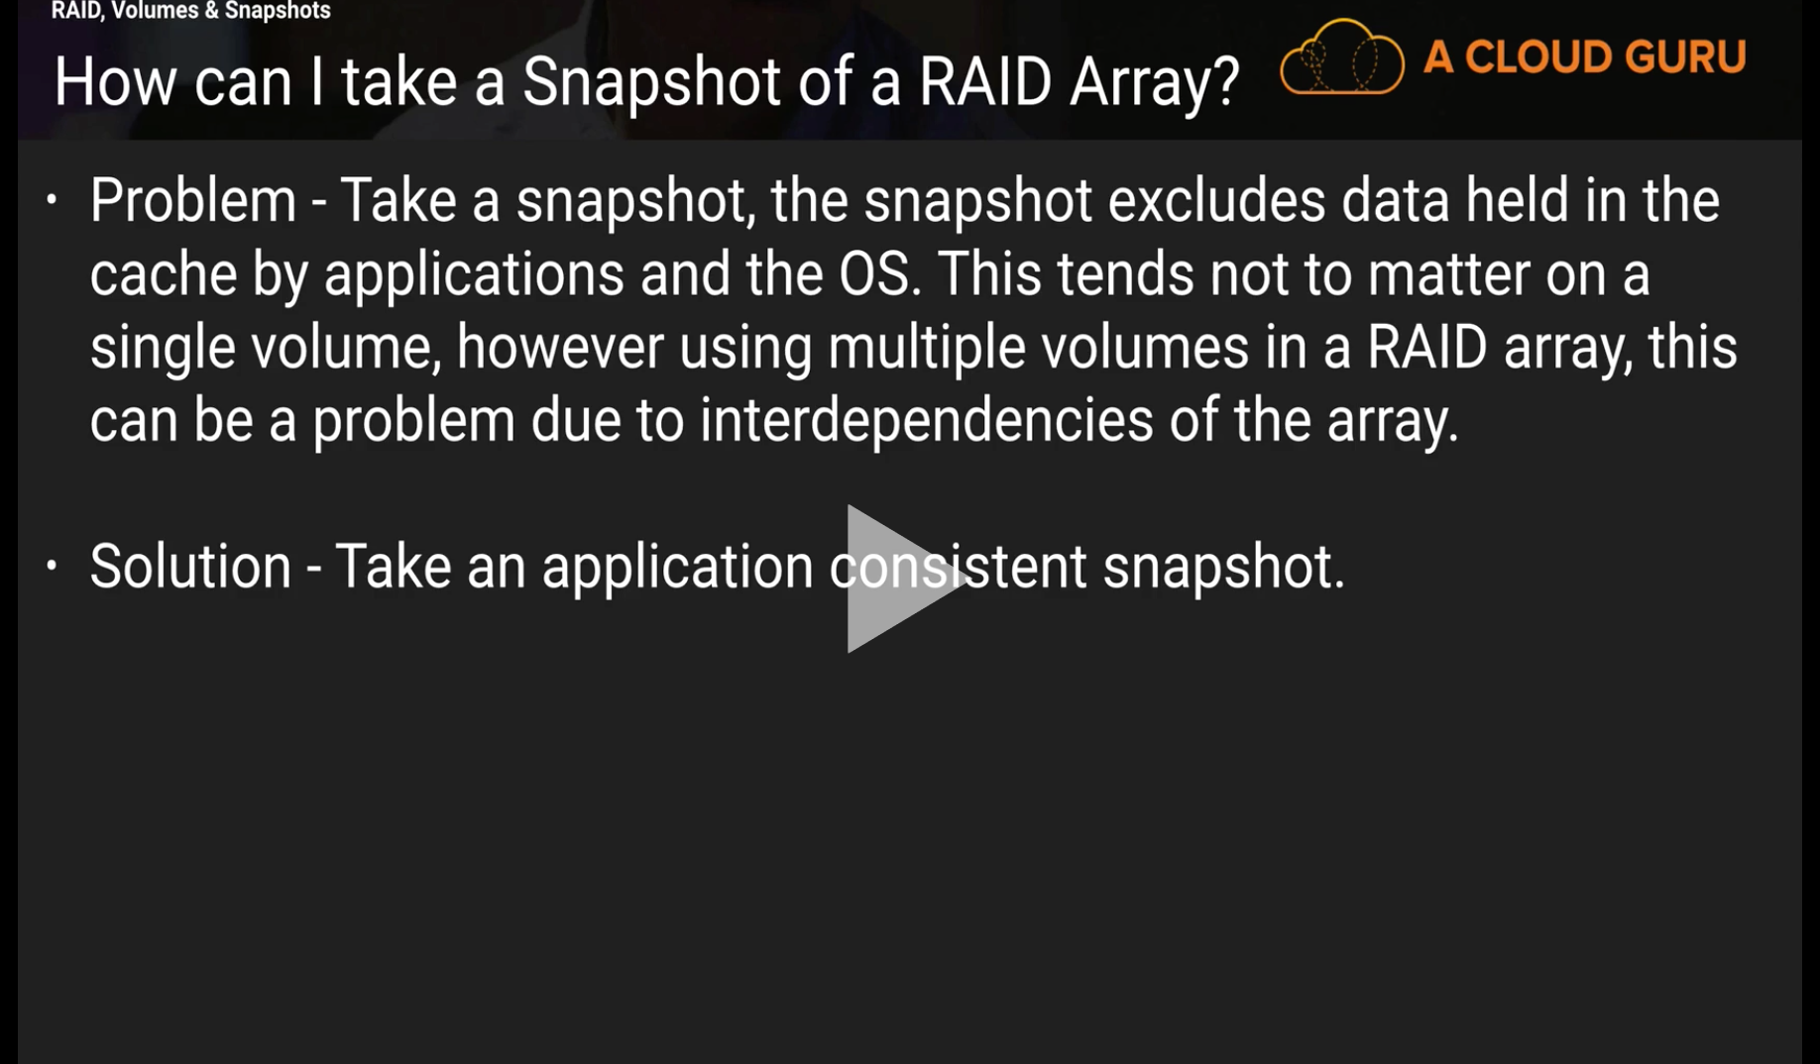

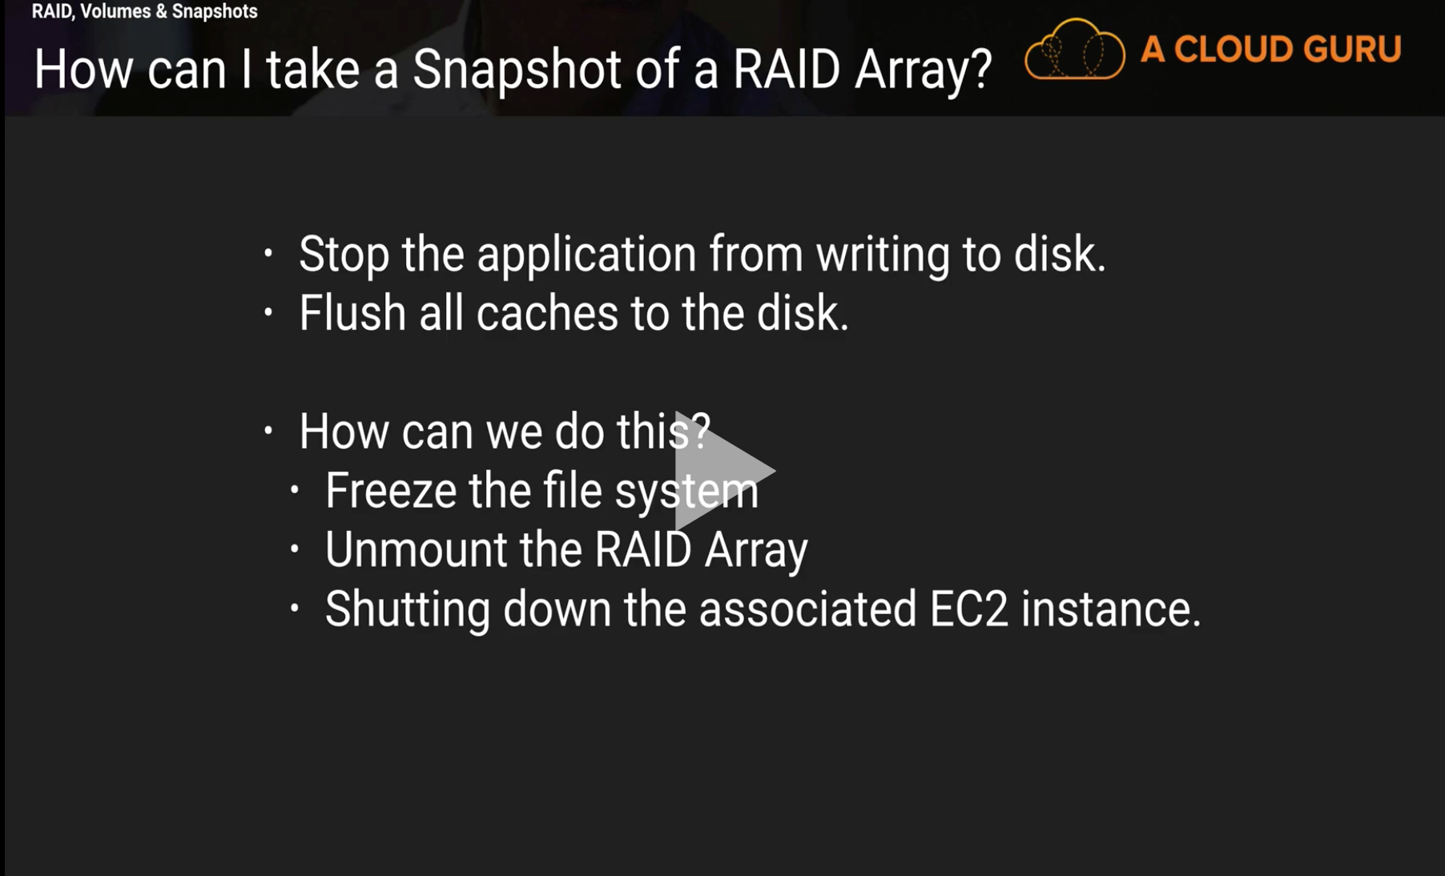

Encrypted Root Device Volumes & Snapshots – Lab

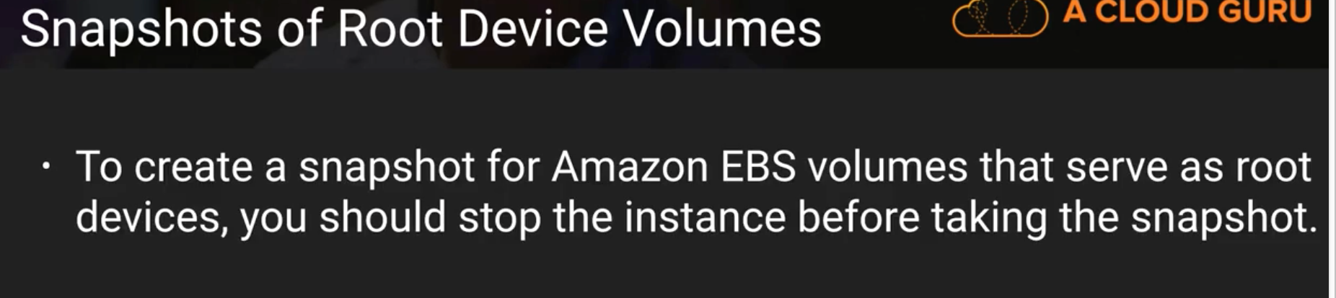
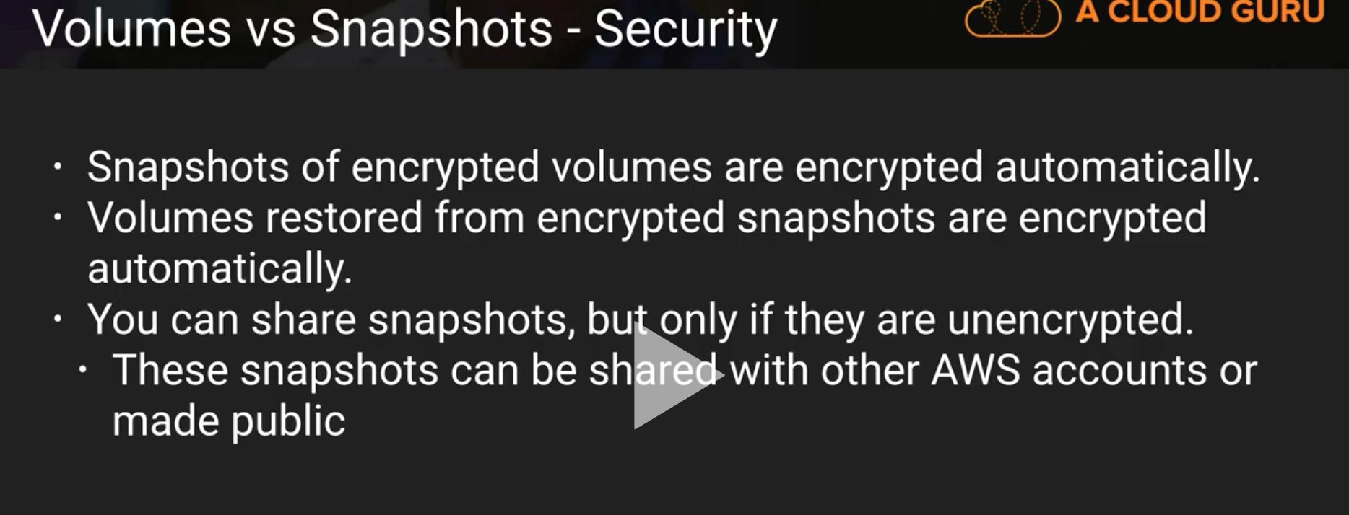

AMI Types

(EMS VS instance store)

I can stop the EBS store, but can’t stop the Instance store, instead it can only be terminated or rebooted.

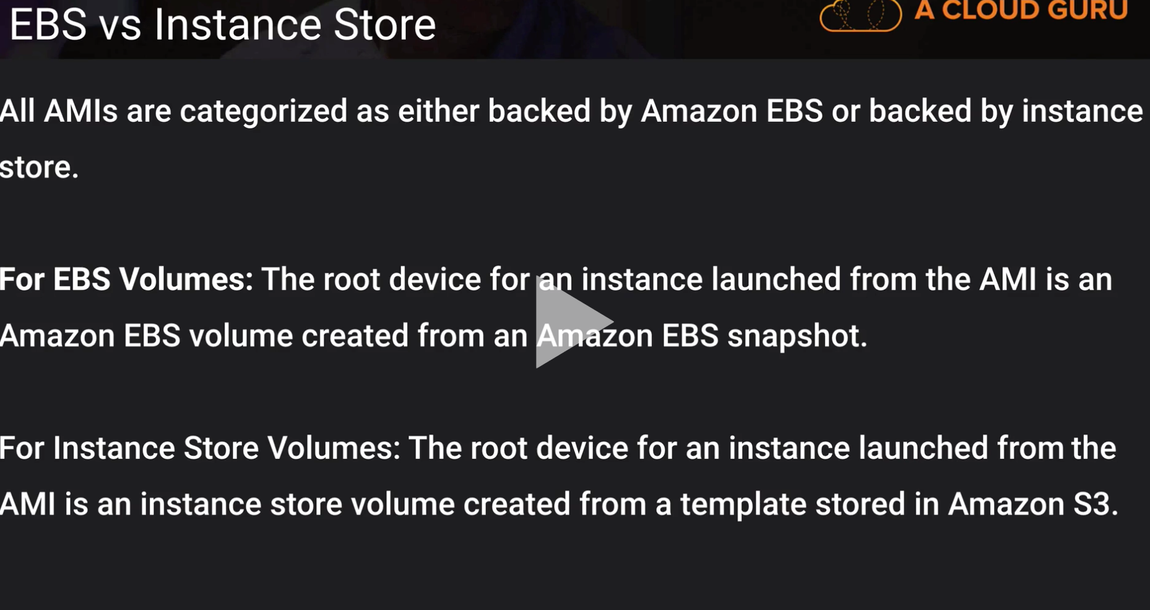
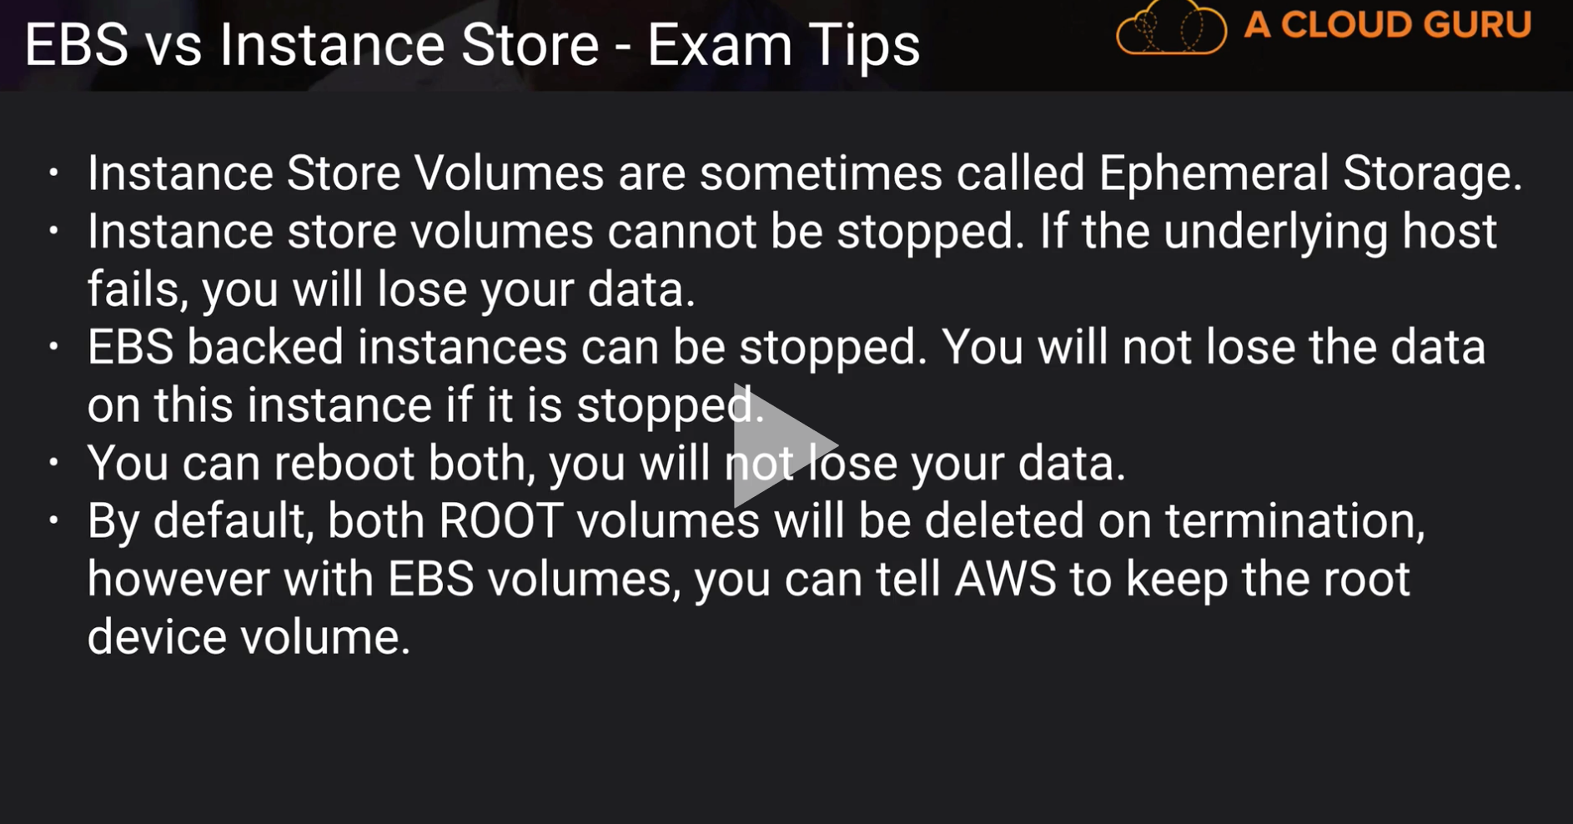

Load Balancers and Health Checks
- Classic Elastic load balancer
- Application Elastic load balancer

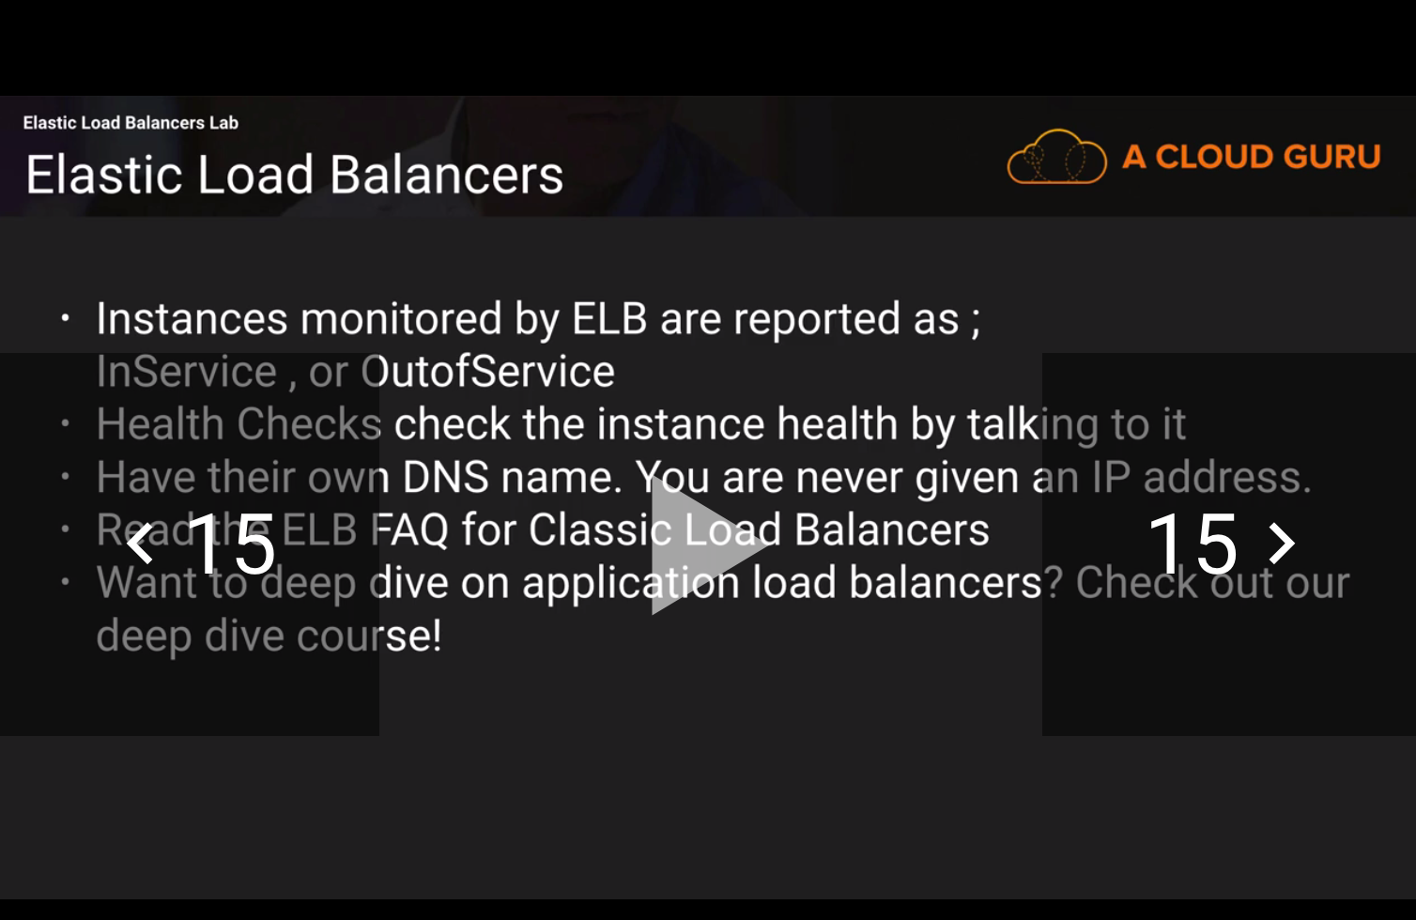

Cloud Watch

